There are two solutions in this project, described below. Both create WinForms apps that randomly generate good-looking images appropriate for use as a desktop wallpaper, or animation background, or whatever else you require.
Hiareyou.com hosts a new image generated from these tools each day. RSS feed of images. Windows theme, fed from RSS feed.
There’s no warranty here, no guarantees, no documentation (other than this file), and the GUIs of the WinForm apps suck ass and frequently lock-up. Sorry. Even the project names are stupid. Oh, and JazzImage just saves right in the project directory, so yeah.
PicMaker: used to generate hiareyou.com artwork for 2011
- Images are heavy in curves, often noisy, sometimes only a gradient
- Image variance is good
- Creates only solid images
- Unlikely to create “boring” images (images that are a single solid color)
- Based basically around creating a gradient, then drawing the color based on a point’s distance to a reference point, but with tons of mutators added-on to make things more interesting
- Runs slower than molasses, and is hard-to-thread correctly
Samples:
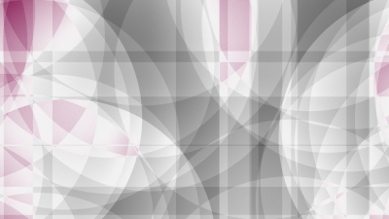

UI: (THIS IS NOT A PRODUCTION-QUALITY APPLICATION)
“Image size” sets the size of the resulting image. There’s no error or sanity checking here, AFAIK.
“Generate” generates a new image.
“Save” brings up a standard save dialog and saves the new image there.
“Save a bunch” saves a bunch of new images, one per day. The field to the right is the number of images to save (default: 10), the field to the right of that is the start date to use (default: today).
“Last Seed” in theory if you feed the same seed into the generator, it’ll produce the same image. In reality, that doesn’t work because of the vagaries of random number generation, and also because of too many aspects of image generation depend on the image size.
JazzImage: used to generate hiareyou.com artwork for 2012
- Resulting images are heavy in grids, parallel lines, and contrasting colors, usually not as noisy, tendency to display spirals
- Image variance is very good (sometimes you’ll be hard-pressed to tell the same algorithm created both images)
- Images can have alpha masks (that is, be transparent)
- Unfortunately more likely to create “boring” images, despite my best efforts
- Based on pseudo-shaders, or at least written after I learned HLSL and vaguely inspired by what I learned
- Runs slightly less slow than molasses
Samples:
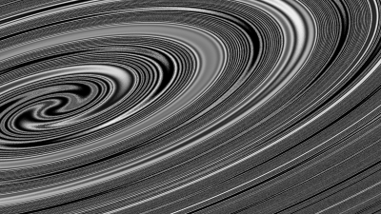

UI: (THIS IS NOT A PRODUCTION-QUALITY APPLICATION)
“New Image” will create a … new image.
“Next Frame” is part of an aborted attempt to make this into a movie creation program, what it does is tells the various “renderers” to increment a frame (what that means is specific to each one) and re-render the image. This does not generate a new image.
“Inverse” runs the “renderers” in reverse order, usually producing an extremely different image to the original. If you inverse a boring image, you frequently get an exciting one. This does not generate a new image.
“Save” saves the image to the application’s folder with a pre-defined file name. (“saved.png” IIRC.)
“Save Bunch” saves a series of images, one for each day, starting at Jan 1, 2012. Date only configurable in the source, alas.
“Movie” saves a series of images, running “Next Frame” between each. Might be fun to play with actually creating a movie, I haven’t really done that yet.

- James Schend, 2011-12-02

